

Bilal Hamdanieh & Marwa Ghraizi

Sunday, April 4, 2021

Structural Bioinformatics

With Dr. Joseph Rebehmed

Paper Presentation

Structural Basis of Enzyme Activity Regulation by the Propeptide of L-lysine α-oxidase Precursor

# **Introduction:**

1. **What is an L-amino acid Oxidase (LAAO)?**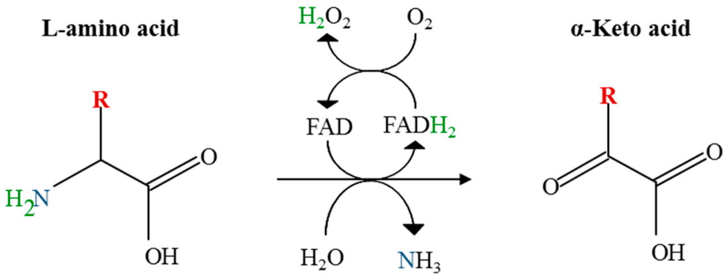

L-Amino acid oxidase (LAAO) is an FAD-dependent enzyme that catalyzes the oxidative deamination of L-amino acid to produce a 2-oxo acid. Because LAAO produces hydrogen peroxide, which is highly toxic to living organisms, during the LAAO catalysis, most of the LAAOs are expressed as precursor proteins and are processed by proteases for activation, through a mechanism called Proteolytic Processing.

1. **Understanding Proteolytic Processing:**

Proteolytic Processing is a major form of post translational modification that occurs when a protease cleaves specific sites of protein cursors, modifying its activity: activation, inhibition, or destruction of the protein’s activity.

Many toxic or harmful proteins are **expressed as inactive precursors** and are **activated by the proteolytic cleavage of the propeptide** when their function is required.

To prevent an undesirable reaction in the cell, the propeptide suppresses the catalytic activity of the hazardous enzymes. The propeptide can also acts as an intramolecular chaperone that assists in proper folding for some enzymes.

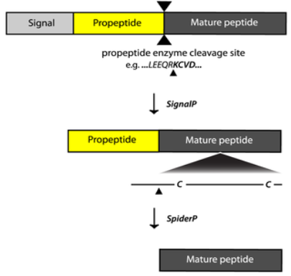

Figure 1: Proteolytic Processing Illustration

1. **Background to a Well-Known LAAO activation; L-Phenylalanine oxidase (PAO):**

Some LAAOs are activated by the removal of the N-terminal pro-sequences and others require more processing. For instance, L-phenylalanine oxidase (PAO), a deaminating and decarboxylating LAAO, consists of two polypeptides produced by cleavage of a single polypeptide precursor. The N-terminal 14 residues and residues 107–108 are removed during maturation. The structural study of the precursor and the mature protein has revealed that the N-terminal 14 residues of the propeptide occupy the pathway to the active site thereby inhibiting the enzyme activity.

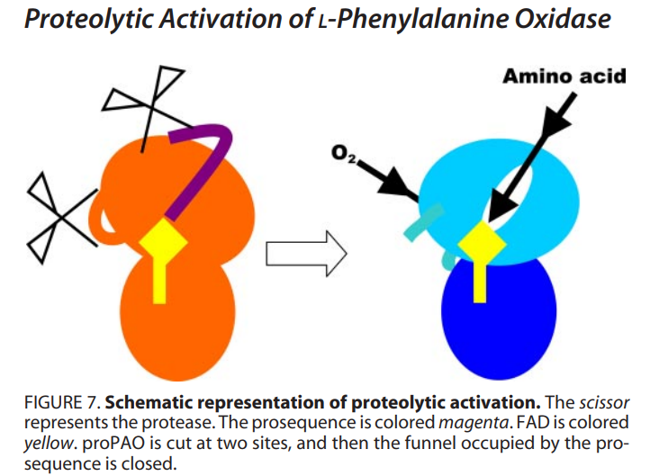

1. **Introducing L-Lysine Oxidase (LysOX):**

L-Lysine oxidase is a member of the LAAO family proteins and has a strict substrate specificity for L-lysine. Like other LAAOs, LysOX is produced as an inactive precursor and is processed by proteases for activation.

LysOX from Trichoderma viride is synthesized as a precursor (**prLysOX**) that **consists of 617 amino acids** whose **N-terminal of 77 residues is cleaved** to produce the mature protein composed of **540 amino acid residues.**

**(1) An Overview of the Crystal Structure of prLysOX:**

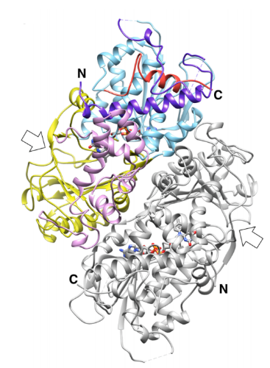A single prLysOX molecule is in an asymmetric unit and forms a dimer with the neighboring molecule related by crystallographic two-fold symmetry. The prLysOX dimer is composed of 5 domains, one subunit is colored by domain, another is colored all gray:

1. **FAD-binding** domain; in Cyan.
2. The **Substrate-Binding** domain; in Yellow.
3. The **Helical domain**; in Magenta.
4. The propeptide region; in Purple.
5. The C-terminal region; in Red.

**(2) The Propeptide Region Constituents:**

Figure 2: Crystal Structure of prLysOX

The propeptide region of prLysOX consists of:

1. An 8-turn amphiphilic α-helix (F6–L34, αN).
2. A proline/ glycine-rich region that forms a repeat of turn structures (G35–P62).
3. A loop with a short helical segment (L63–R72)
4. A C-terminal eight residues (L71–A78).

**(3) The Mature Enzyme LysOX Domains:**

After Proteolytic Processing, the mature LysOX is left with three Domains:

1. FAD-binding domain.
2. The Substrate-binding domain.
3. The Helical domain.

* Research Question: Since the N-terminal propeptide is much longer than that of PAO, prLysOX is expected to use a different way to suppress the enzyme activity than PAO.

This study aims to understand the mechanism of how the propeptide region of LysOX regulates the enzyme activity.

# **Results & Discussion:**

prLysOX showed a low specific activity of less than 1/50 of mature LysOX, suggesting that cleavage of the propeptide region activates LysOX.

1. **Understanding how the propeptide of L-Lysine Suppresses the Enzyme Activity and its Activation via Proteolytic Cleavage:**

Propeptides of enzyme precursors often block their active sites or the entrances to the active sites from substrate binding, and thereby inhibit the enzyme activity. PrLysOX however uses a different strategy.

The Structure of prLysOX revealed that the propeptide region of prLysOX does not cover the entrance nor the tunnel to the active site and does not directly interact with the residues involved in substrate binding or reaction.

**The Major Structural Features of the Propeptide in prLysOX**

|  |
| --- |
| **prLysOX** |
| The N-terminal pro-sequence of 77 amino acids folds into a sub-domain on the FAD-binding with the C-terminal region. |
| The N-terminal region of αN pushes up α5 and α6 straightening the kink between α4 and α5. |
| The αN aliphatic side, Valine10 & Tryptophan14, form hydrophobic interactions with Isoleucine288. |
| Phenylalanine291 is surrounded by hydrophobic residues of Phenylalanine6, Alanine7, & Valine10 in αN. |
| Hydrophilic interaction is observed between αN and α9: Aspartate-289 and Aspartate-292 in α9 make a charge interaction with Arginine-11 in αN. |

These structural features **shift α9 away, which is located above the funnel substrate binding site, expanding the space** of the substrate binding pocket. Moreover, the structural change shifts Threonin276 resulting in the removal of the water mediating the interaction between L-lysine and Aspartate392.

As a result, the propeptide region of prLysOX indirectly changes the active site structure to inhibit the enzyme activity.

Conversely, removal of the propeptide region by proteolysis induces the conformational change of the helical domain which induces the movement of the active site residues to the proper positions required to activate the enzyme.

**Location of the Helical Domains with Respect to the Substrate Binding Site in**

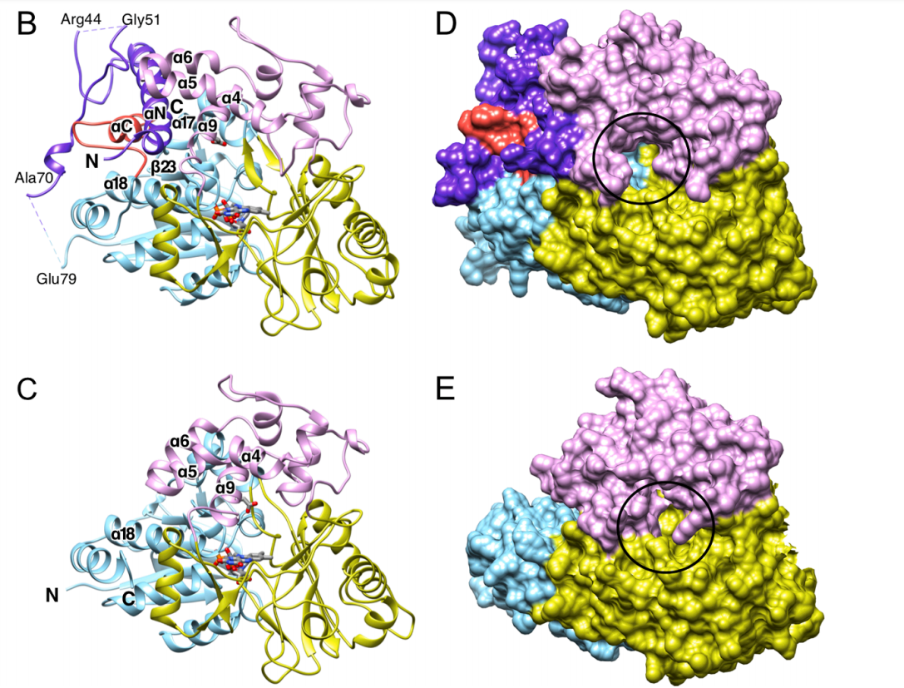**prLysOX vs Lys OX**

**Expansion of the Space of the Substrate Binding Pocket**

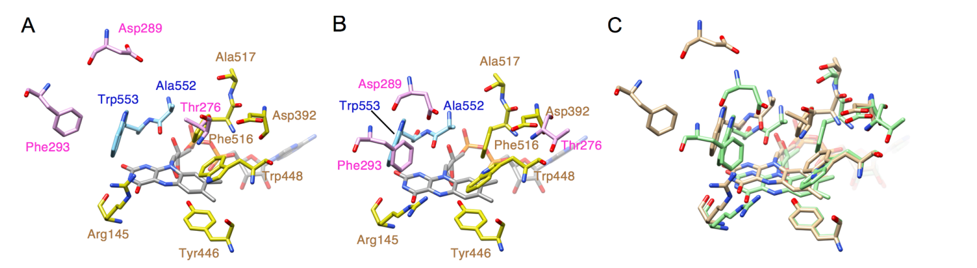

1. **Activation of prLysOX in response to Environmental Changes:**

The optimum pH and temperature of the precursor are significantly different than those of the mature protein.

The side chain of L-lysine is recognized by two aspartate residues, and the surface around the substrate-binding site is negatively charged by acidic residues (Kondo et al., 2020). The side chain pKa of glutamate and aspartate is around 4.0, and thus acidic environment is likely to be unsuitable for the L-lysine binding to LysOX. In fact, the relative activity of mature LysOX at pH 4.0 is 20% of its maximum, and the Km value of prLysOX at pH 4.0 is 20 times larger than that of LysOX at pH 7.4.

***(1) pH:***

* Optimum pH of prLysOX is 4.0 at which the activity was thirty folds higher than at pH=7.0.
* 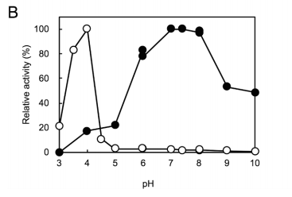Optimum pH of mature LysOX at 40 ◦C was pH 7.4.

Figure 3: Effect of pH on the enzyme activities of prLysOX (open circle) and mature LysOX (closed circle) at 40 ◦C.

*Then why prLysOX shows the maximum activity at pH 4.0?* The sharp and large change of the enzyme activity implies a structural change of prLysOX. The calculated isoelectric point of the propeptide region is 9.29, whereas that of the mature LysOX is 5.47. The propeptide region contains 13 positively charged residues (nine arginine and four lysine residues) and 11 negatively charged residues (4 aspartic acid and 7 glutamic acid residues). Thus, the propeptide region is positively charged (Fig. 3D).

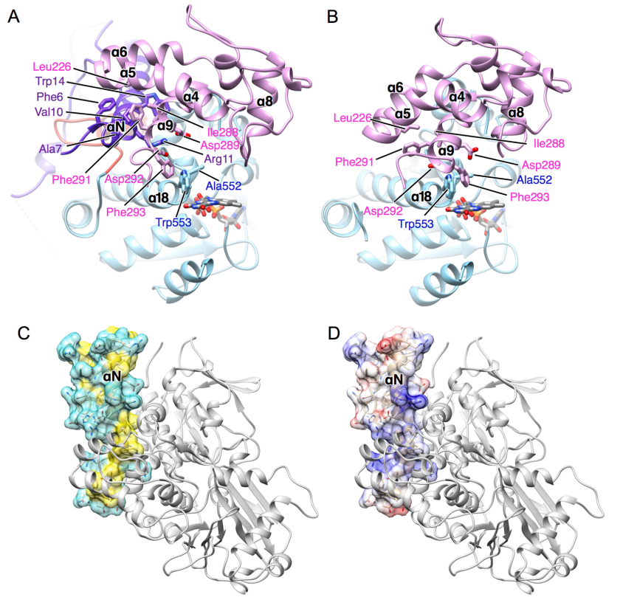

The positively charged residues in αN, such as R11, R17, and R20, interact with the acidic residues, such as D231, D235, D289, D292, and E593. These interactions contribute to stabilize the propeptide structure.

Because the side chains of glutamate and aspartate residues are neutralized under acidic condition, these interactions will be lost around pH 4.0, leading to destabilize the propeptide structure. As a result, the propeptide region may be disordered around pH 4.0, and the prLysOX structure may be changed into a similar structure to LysOX.

***(2) Temperature:***

* Optimum temperature of prLysOX at pH 4.0 was 50 ◦C
* Optimum temperature of LysOX at pH 7.4 was also 50 ◦C

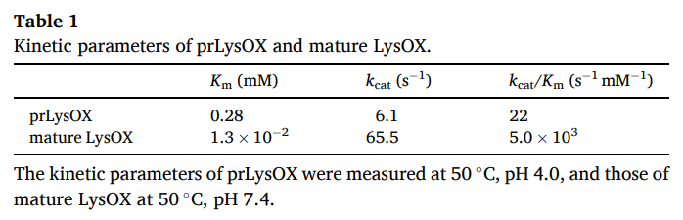 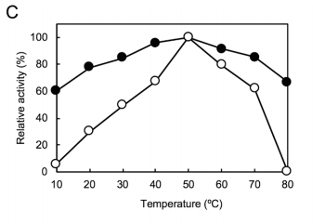

Figure 4: Temperature dependence of the enzyme activities of prLysOX and mature LysOX

The optimum temperature therefore for both prLysOX and LysOX is the same, and temperature does not contribute to the modulation of prLysOX.

***(3) Substrate Concentration:***

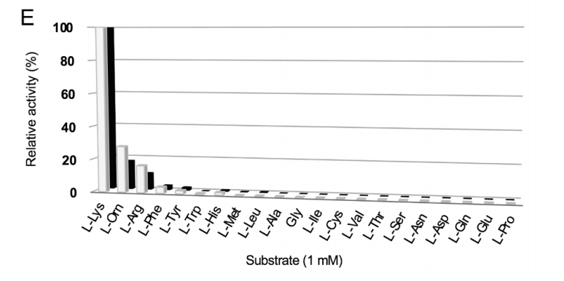The substrate specificity of the precursor. prLysOX exhibits a similar substrate specificity profile to LysOX (Fig. 1E). L-ornithine, L-arginine, L-phenylalanine, L-tyrosine, and L-histidine showed weak activity, but no activity was detected for other amino acids. Therefore, prLysOX retains strict specificity for L-lysine.

However, we have already built that the structure of prLysOX at the substrate binding site is expanded, which is likely to increase the binding affinity for amino acids with bulky side chains while reduces the affinity for L-lysine. The question remains: How does prLysOX retain strict specificity for L-lysine? To solve this mystery, the scholars determined the structure of prLysOX in complex with L-lysine.

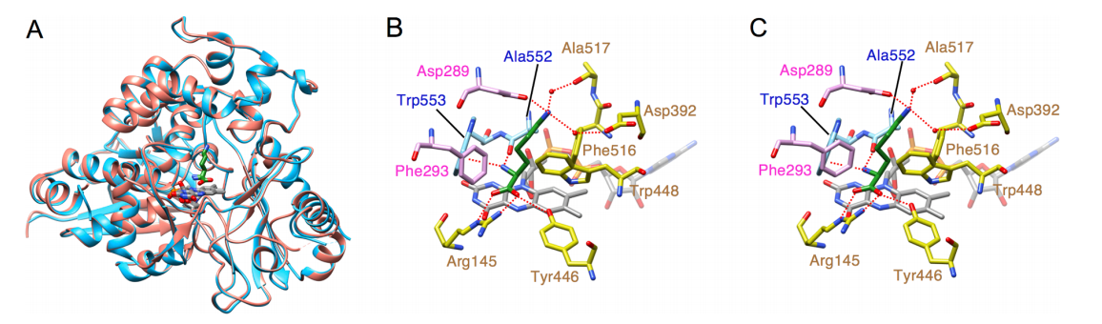 Surprisingly, the structure is the same as that of LysOX-Lys. The propeptide region and the C-terminal helix is disordered. L-lysine is bound in the same manner in prLysOX as LysOX-Lys, although the density of L-lysine in prLysOX is not as clear as in LysOX.

Figure 5: Structural comparison of prLysOX soaked in L-lysine solution and LysOX-Lys.

(A) Superimposition of the structure of prLysOX soaked in L-lysine solution (orange) and that of LysOX-Lys (light blue). FAD (gray) and the substrate L-lysine (green) are indicated by stick.

(B) (C) Close up view of the substrate-binding site of prLysOX-Lys (B) and LysOX-Lys (C). The substrate L-lysine is colored with the same color as (A). The protein residues and FAD are shown as in (A). The water molecules involved in the substrate recognition are shown in red balls. The red dot lines indicate the possible hydrogen bonding network and the cation pi interaction involved in substrate recognition.

PrLysOX in the crystal shows an interesting structure that is a mixture of the structures of prLysOX and the LysOX-Lys with the occupancy ratio of 0.57:0.43. Very weak but significant density corresponding to L-lysine was observed in the active site. These results suggest that prLysOX can adopt two conformations and L-lysine binds only to the LysOX like structure. Thereby prLysOX retains strict specificity for L-lysine.

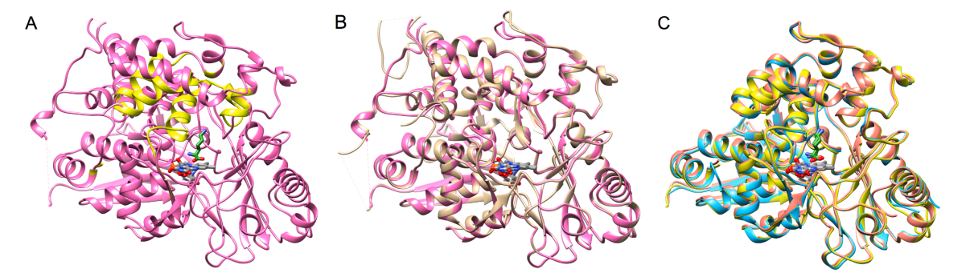

Figure 6: Two conformations in the crystal structure of the prLysOX soaked in 1 M L-lysine solution. (A) Ribbon representation of the crystal structure of prLysOX soaked in 1 M L-lysine solution. The conformation similar to ligand-free prLysOX (conformation-1) is colored in magenta and the other conformation similar to LysOX-Lys (conformation-2) in yellow. (B) Superimposition of the structures of conformation-1 (magenta) and prLysOX (light brown). (C) Superimposition of the structures of conformation-2 (yellow), prLysOX-Lys (orange), and LysOX-Lys (light blue). (For interpretation of the references to color in this figure legend, the reader is referred to the web version of this article.)

# **Methodology:**

1. **Expression and purification of prLysOX**. prLysOX is expressed in Escherichia coli SoluBL21. Purification is done at pH of 7.4 and Temperature ranging between 0◦C to 4◦C.
2. **Proteolysis of the N-terminal propeptide**. prLysOX was incubated with proteases at 37◦C for 4 hours.
3. **Determination of N-terminal amino acid sequence**. The N-terminal amino acid sequence was determined by Edman degradation using PPSQ-31A protein sequencer machine (Manufacturer: Shimadzu)
4. **Enzyme assay**. The enzyme activity was measured by detecting hydrogen peroxide using a color development method and a spectrophotometer UV mini 1240 (Manufacturer: Shimadzu) to monitor the absorbance of 505 nm wavelength at 40℃ for 3 min.
5. **Crystallization, data collection, and structure determination of prLysOX and its complex with L-lysine**.

(1) Crystallization screening was done using screening kits Cryo I and II (Emerald Biostructures) and Crystal Screen I and II machines (Hampton Research).

(2) The structures were determined by the molecular replacement method using the structure of LysOX (PDB ID: 3X0V) as a search model with Phaser.

(3) The atomic models were built with Coot, a software similar to Chimera, and their resolution was refined with another called PHENIX.

# **Conclusion:**

In addition to activation of prLysOX by proteolytic cleavage, the former can be activated quickly in response to the environmental change, for example, acidification, without proteolytic processing. Moreover, prLysOX can adopt two conformations and L-lysine binds only to the LysOX like structure.